**Nazwisko i imię …………………………………………………………………………………………………… Nr dziennika………….**

Zadanie Listy i CSS

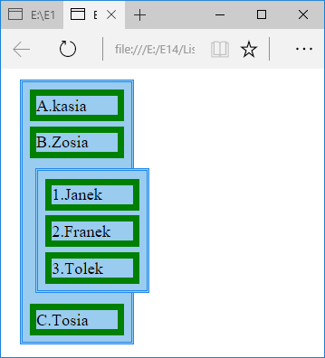

# 

<html>

<head>

<style rel="stylesheet" type="text/css" >

ol {

display: block; list-style: none; margin: 0; width: 200px; padding: 2px 2px 1px 2px; background-color: #9ce; border: 3px double #28e;

}

</style>

</head>

<body>

<ol>

<li>1.Ala am kota</li>

<li>2.Ala am kota</li>

<li>3.Ala am kota</li>

</ol>

</body>

</html>

<html>

<head>

<style rel="stylesheet" type="text/css" >

Li { border: 3px solid green;margin:1px;}

</style>

</head>

<body>

<ol>

<li>1.Ala am kota</li>

<li>2.Ala am kota</li>

<li>3.Ala am kota</li>

</ol>

</body>

</html>

<html>

<head>

<style rel="stylesheet" type="text/css" >

ol {

display: block; list-style: none; margin: 0; width: 200px; padding: 2px 2px 1px 2px; background-color: #9ce; border: 3px double #28e;

}

Li { border: 3px solid green;margin:1px;}

</style>

</head>

<body>

<ol>

<li>1.Ala am kota</li>

<li>2.Ala am kota</li>

<li>3.Ala am kota</li>

</ol>

</body>

</html>