Nazwisko i imię …………………………………………………………………………………………………… Nr dziennika………….

Zadanie Listy i CSS
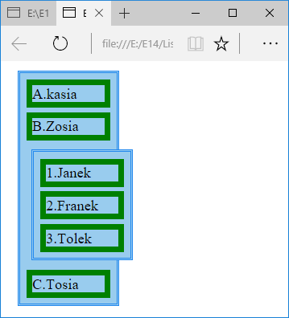
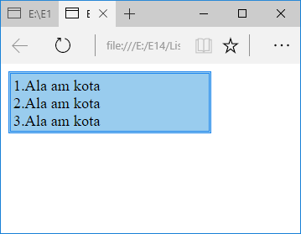
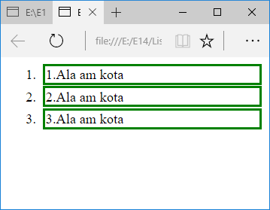
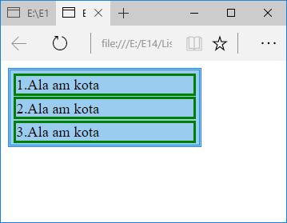
<html>
<head>
<style rel="stylesheet" type="text/css" >
ol {
display: block; list-style: none; margin: 0; width: 200px; padding: 2px 2px 1px 2px; background-color: #9ce; border: 3px double #28e;
}

</style>
</head>
<body>
<ol>
<li>1.Ala am kota</li>
<li>2.Ala am kota</li>
<li>3.Ala am kota</li>
</ol>
</body>
</html>

<html>
<head>
<style rel="stylesheet" type="text/css" >
Li { border: 3px solid green;margin:1px;}
</style>
</head>
<body>
<ol>
<li>1.Ala am kota</li>
<li>2.Ala am kota</li>
<li>3.Ala am kota</li>
</ol>
</body>
</html>

<html>
<head>
<style rel="stylesheet" type="text/css" >
ol {
display: block; list-style: none; margin: 0; width: 200px; padding: 2px 2px 1px 2px; background-color: #9ce; border: 3px double #28e;
}
Li { border: 3px solid green;margin:1px;}
</style>
</head>
<body>
<ol>
<li>1.Ala am kota</li>
<li>2.Ala am kota</li>
<li>3.Ala am kota</li>
</ol>
</body>
</html>

