Menu nawigacyjne - MauiApp19
Film

Uruchamiamy

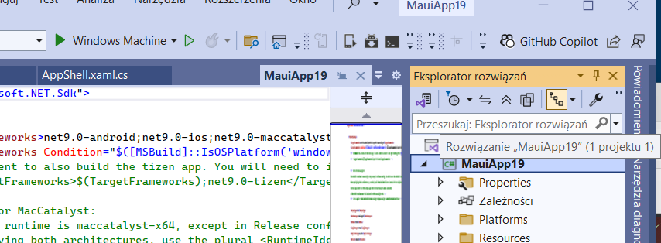
Prawy guzik myszy
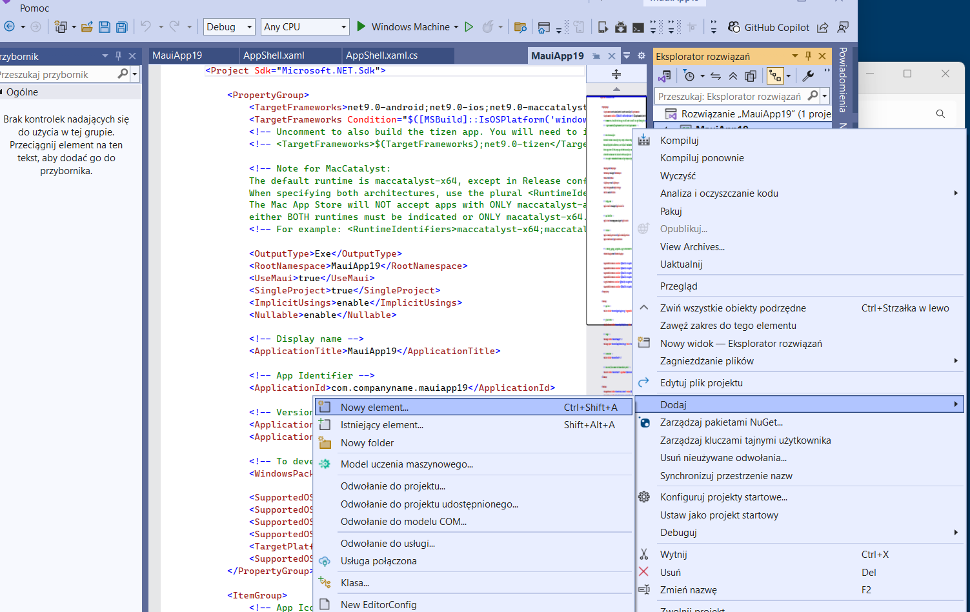
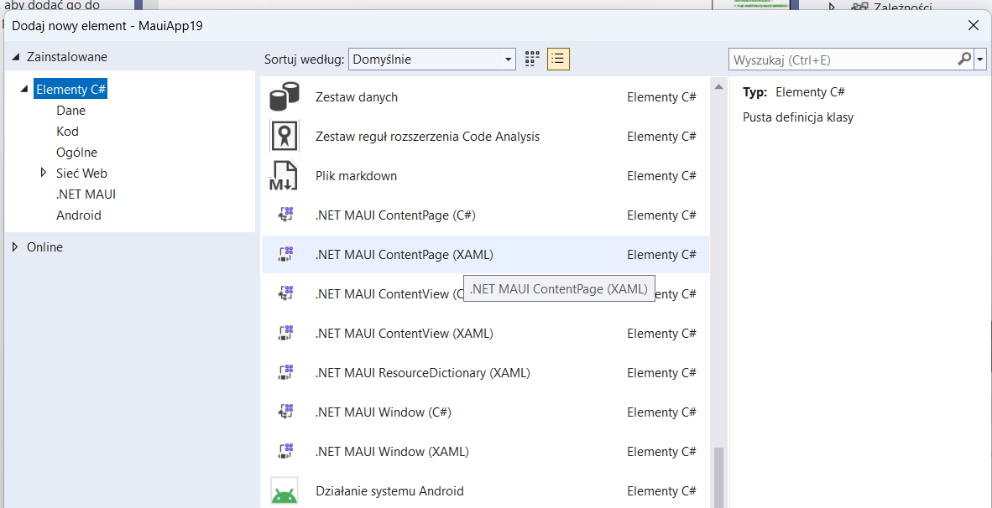

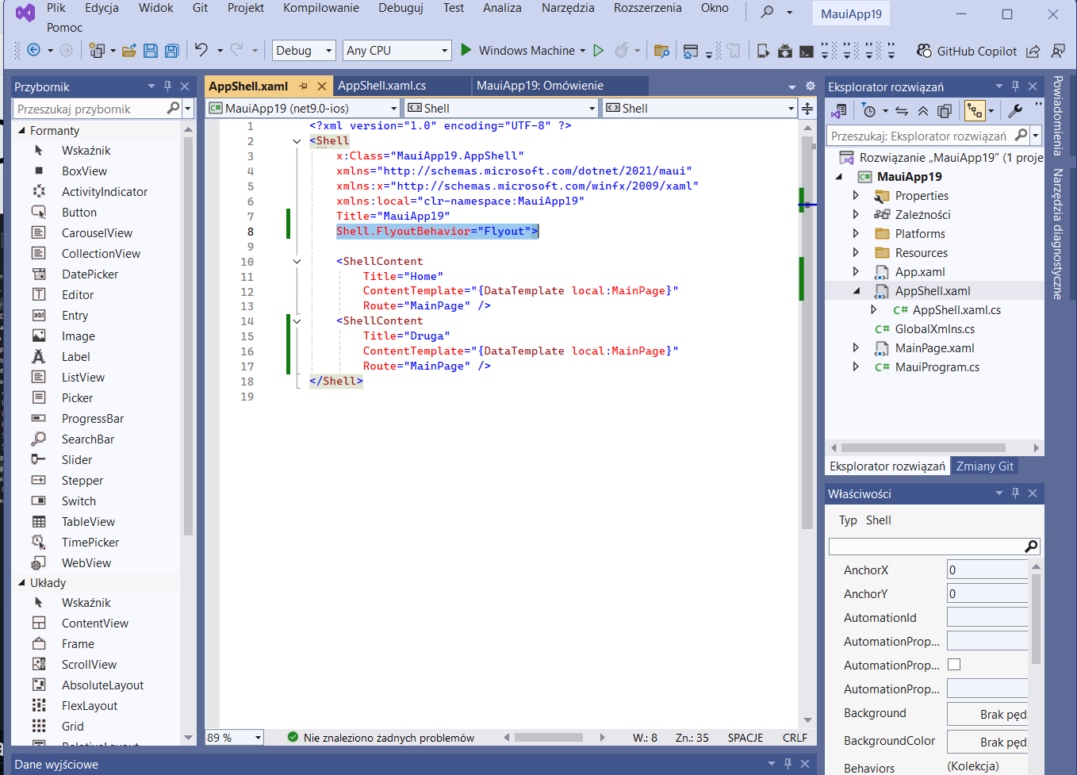

Co to jest - Shell.FlyoutBehavior="Flyout"
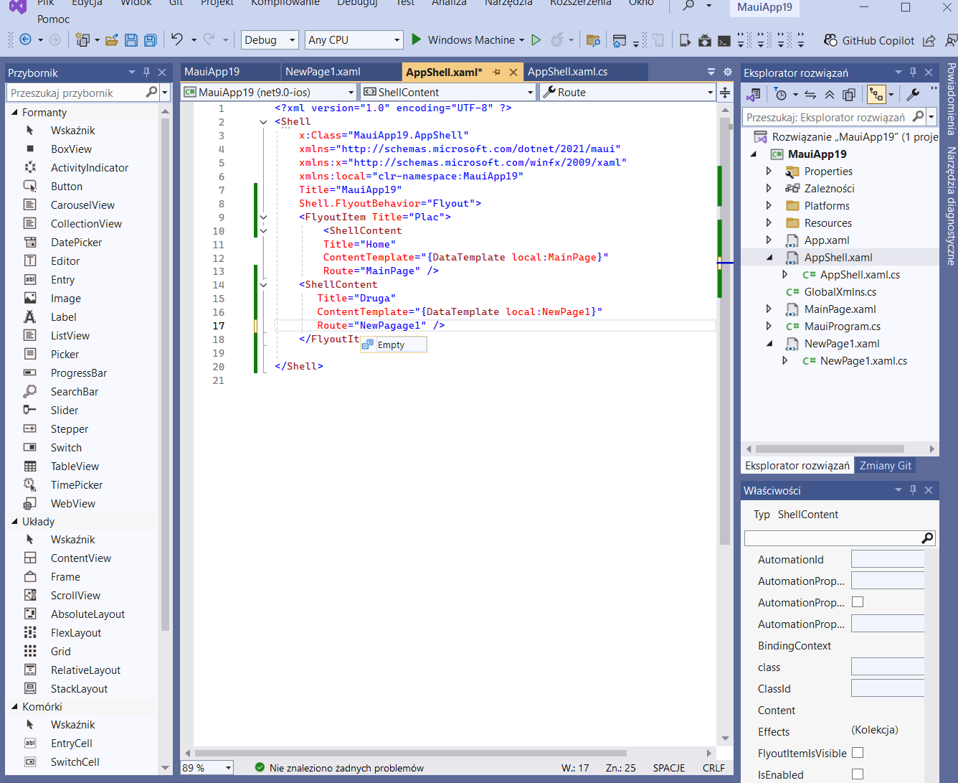
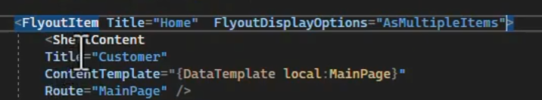

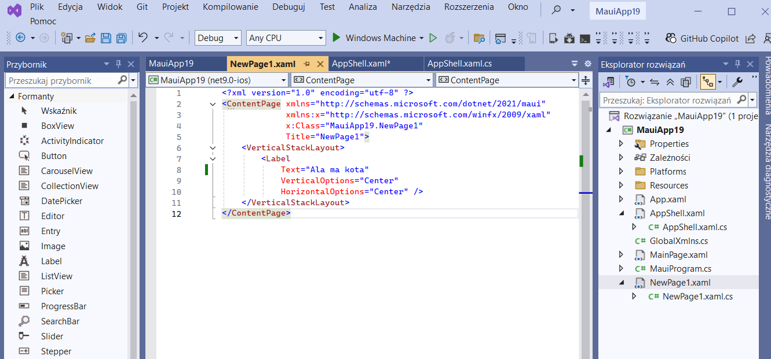
Po uruchomieniu
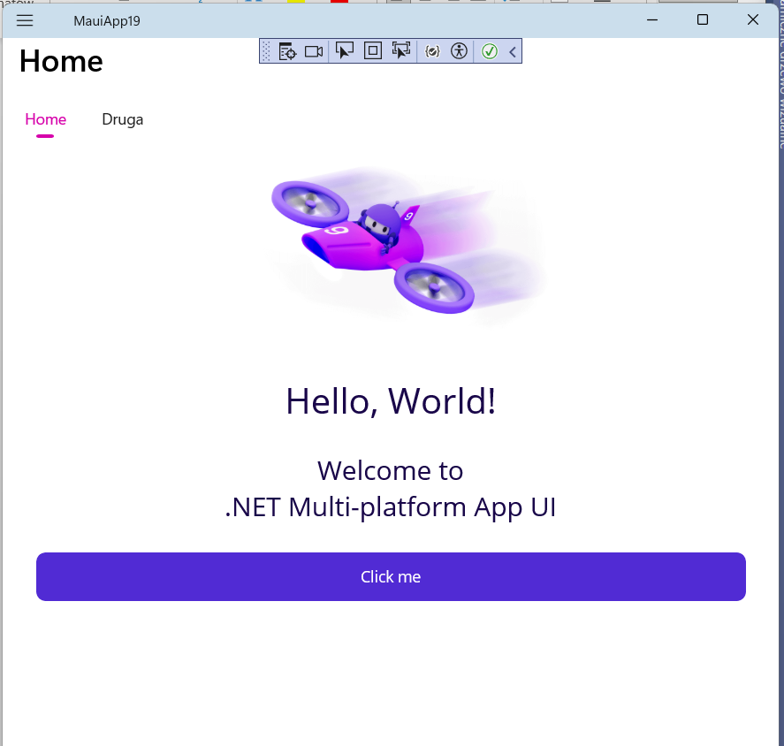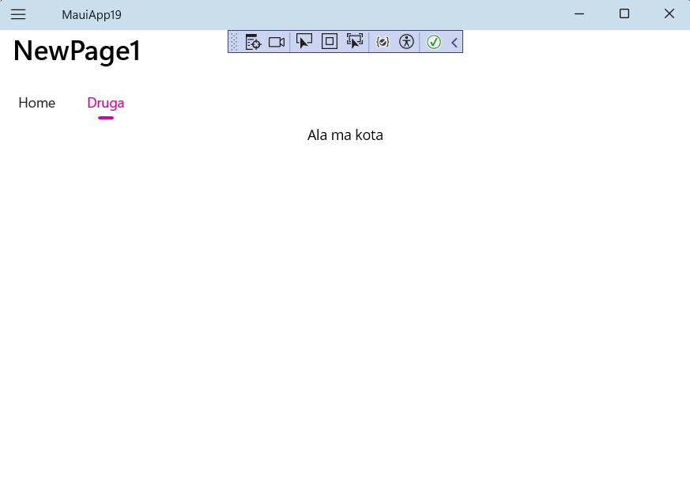

Dodawanie ikonek
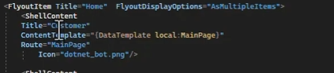

Pasek na dole
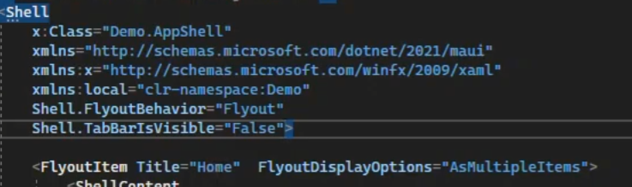
Nagłówek
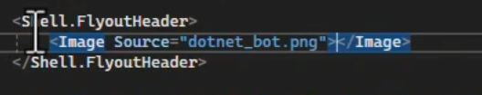

Siatka w meni
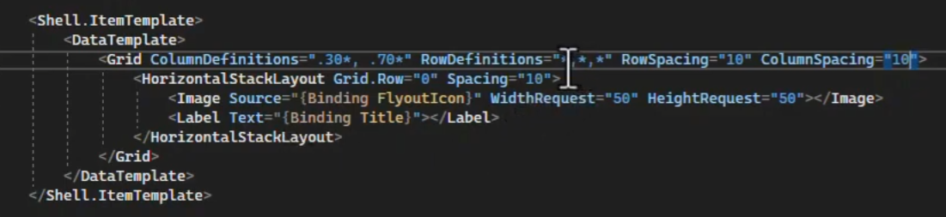
Po wszystkim
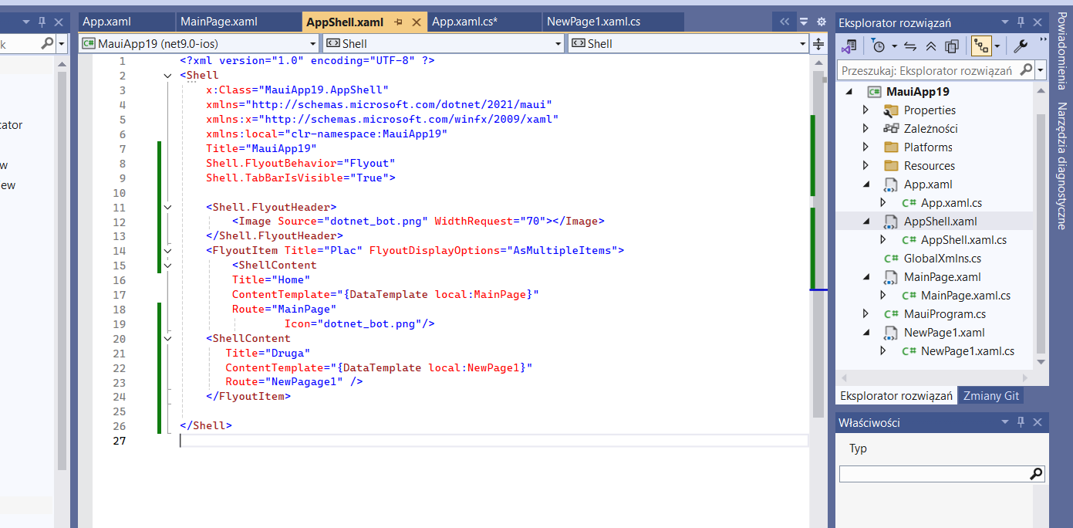

Film
Zadania
- Każda strona sygnowana imieniem i nazwiskiem
- Wstawić meni górne lub dolne
- W meni wstawiamy ikonki
- Układ zdjęć
  - np.: 3x2

- Kolor tła strony
kolory |  |  |  |  |  |  | NRD dla Koloru  1 strony |  |  |  | NRD dla Koloru  2 strony |  |  |  | NRD dla Koloru  3 strony |  |  |  |  | NRD dla Koloru  4 strony
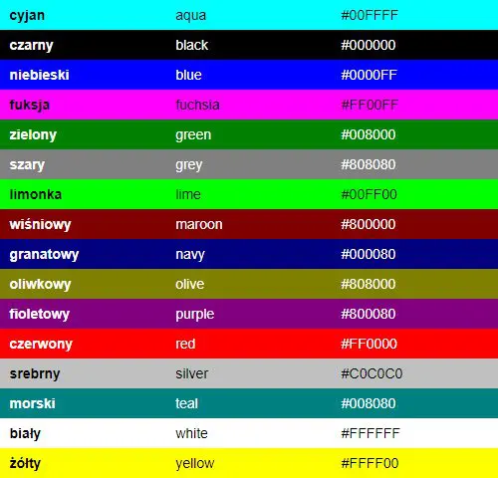 |  |  |  |  |  |  | 18 |  |  |  | 16 |  |  |  | 17 |  |  |  |  | 15
 |  |  |  |  |  |  | 19 |  |  |  | 17 |  |  |  | 18 |  |  |  |  | 16
 |  |  |  |  |  |  | 20 |  |  |  | 18 |  |  |  | 19 |  |  |  |  | 17
 |  |  |  |  |  |  | 21 |  |  |  | 19 |  |  |  | 20 |  |  |  |  | 18
 |  |  |  |  |  |  | 22 |  |  |  | 20 |  |  |  | 21 |  |  |  |  | 19
 |  |  |  |  |  |  | 23 |  |  |  | 21 |  |  |  | 22 |  |  |  |  | 20
 |  |  |  |  |  |  | 24 |  |  |  | 22 |  |  |  | 23 |  |  |  |  | 21
 |  |  |  |  |  |  | 25 |  |  |  | 23 |  |  |  | 24 |  |  |  |  | 22
 |  |  |  |  |  |  | 26 |  |  |  | 24 |  |  |  | 25 |  |  |  |  | 23
 |  |  |  |  |  |  | 27 |  |  |  | 25 |  |  |  | 26 |  |  |  |  | 24
 |  |  |  |  |  |  | 28 |  |  |  | 26 |  |  |  | 27 |  |  |  |  | 25
 |  |  |  |  |  |  | 29 |  |  |  | 27 |  |  |  | 28 |  |  |  |  | 26
 |  |  |  |  |  |  | 30 |  |  |  | 28 |  |  |  | 29 |  |  |  |  | 27
 |  |  |  |  |  |  | 16 |  |  |  | 29 |  |  |  | 30 |  |  |  |  | 28
 |  |  |  |  |  |  | 17 |  |  |  | 30 |  |  |  | 15 |  |  |  |  | 29
 |  |  |  |  |  |  | 18 |  |  |  | 15 |  |  |  | 16 |  |  |  |  | 30
 | NRD |  | 1 | 2 | 3 | 4 |  | 5 | 6 | 7 |  | 8 | 9 | 10 |  | 11 | 12 | 13 | 14 |  | 15 |  | 16
 | NRD |  | 17 | 18 | 19 | 20 |  | 21 | 22 | 23 |  | 24 | 25 | 26 |  | 27 | 28 | 29 | 30 |  | 31 |  | 32
 | Układ plików graficznych | S1 | 2x4 | 2x3 | 1x4 | 2x4 |  | 2x3 | 1x4 | 2x4 |  | 2x3 | 1x4 | 2x4 |  | 2x3 | 1x4 | 2x4 | 2x3 |  | 1x4 |  | 2x4
 | Układ plików graficznych | S2 | 3x3 | 2x2 | 3x3 | 2x2 |  | 3x3 | 2x2 | 3x3 |  | 2x2 | 3x3 | 2x2 |  | 3x3 | 2x2 | 3x3 | 2x2 |  | 3x3 |  | 2x2
 | Układ plików graficznych | S3 | 5x2 | 4x1 | 4x2 | 5x1 |  | 5x2 | 4x1 | 4x2 |  | 5x1 | 5x2 | 4x1 |  | 4x2 | 5x1 | 5x2 | 4x1 |  | 4x2 |  | 5x1
 | Układ plików graficznych | S4 | 1 | 1 | 1 | 1 |  | 1 | 1 | 1 |  | 1 | 1 | 1 |  | 1 | 1 | 1 | 1 |  | 1 |  | 1
 | Liczba stron |  | 3 | 4 | 3 | 4 |  | 3 | 4 | 3 |  | 4 | 3 | 4 |  | 3 | 4 | 3 | 4 |  | 3 |  | 4

Sprawozdanie obejmuje
- Kody każdej ze stron
  - *.Xmal
  - *.cs
- Zrzuty ekranu każdej strony

