W docx jest skrócony tutorial z tej strony po angielsku + na końcu jeden dodatkowy program:

<http://docs.oracle.com/javase/tutorial/getStarted/cupojava/win32.html>

tutorial netbeans:

<http://docs.oracle.com/javase/tutorial/getStarted/cupojava/netbeans.html>

https://mail.google.com/mail/u/0/images/cleardot.gif

**Hello World!" for Microsoft Windows**

1. **The Java SE Development Kit 7 (JDK 7)**

You can [download the Windows version now](http://www.oracle.com/technetwork/java/javase/downloads/index.html). (Make sure you download the **JDK**, *not* the JRE.)

1. **A text editor**

In this example, we'll use Notepad, a simple editor included with the Windows platforms. You can easily adapt these instructions if you use a different text editor.

These two items are all you'll need to write your first application.

**Create a Source File**

First, start your editor. You can launch the Notepad editor from the **Start** menu by selecting **Programs > Accessories > Notepad**. In a new document, type in the following code:

/**  * The HelloWorldApp class implements an application that  * simply prints "Hello World!" to standard output.  */ class HelloWorldApp {     public static void main(String[] args) {         System.out.println("Hello World!"); // Display the string.     } }

Save the code in a file with the name HelloWorldApp.java. To do this in Notepad, first choose the **File > Save As** menu item. Then, in the **Save As** dialog box:

1. Using the **Save in** combo box, specify the folder (directory) where you'll save your file. In this example, the directory is java on the C drive.
2. In the **File name** text field, type "HelloWorldApp.java", including the quotation marks.
3. From the **Save as type** combo box, choose **Text Documents (*.txt)**.
4. In the **Encoding** combo box, leave the encoding as ANSI.

When you're finished, the dialog box should look like this.

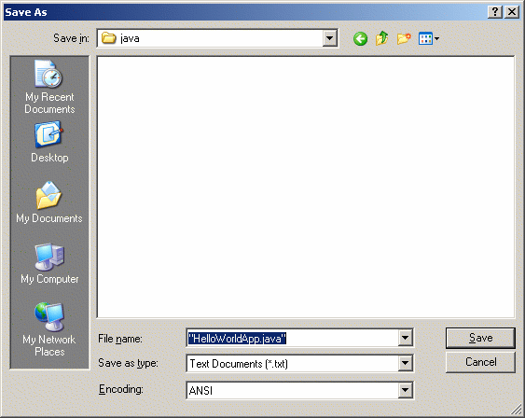

The Save As dialog just before you click **Save**.

Now click **Save**, and exit Notepad.

**Compile the Source File into a .class File**

Bring up a shell, or "command," window. You can do this from the **Start** menu by choosing **Command Prompt** (Windows XP), or by choosing **Run...**and then entering cmd. The shell window should look similar to the following figure.

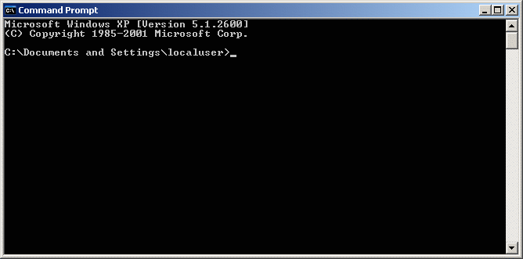

A shell window.

The prompt shows your *current directory*. When you bring up the prompt, your current directory is usually your home directory for Windows XP (as shown in the preceding figure.

To compile your source file, change your current directory to the directory where your file is located. For example, if your source directory is java on the Cdrive, type the following command at the prompt and press **Enter**:

**cd C:\java**

Now the prompt should change to C:\java>.

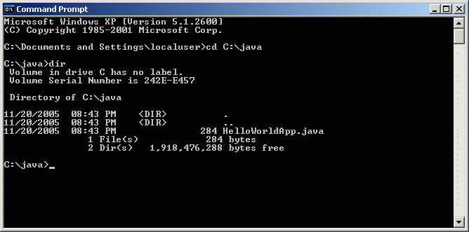

Directory listing showing the .java source file.

Now you are ready to compile. At the prompt, type the following command and press **Enter**.

**javac HelloWorldApp.java**

The compiler has generated a bytecode file, HelloWorldApp.class. At the prompt, type dir to see the new file that was generated, as shown in the following figure.

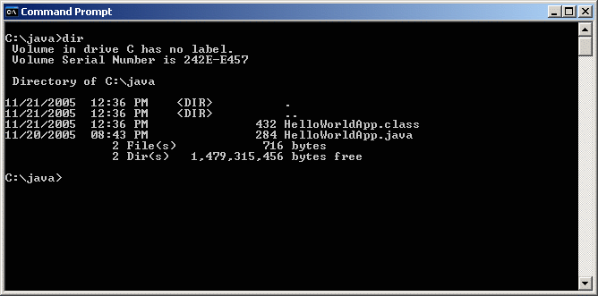

Directory listing, showing the generated .class file

Now that you have a .class file, you can run your program.

**Run the Program**

In the same directory, enter the following command at the prompt:

**java HelloWorldApp**

The next figure shows what you should now see:

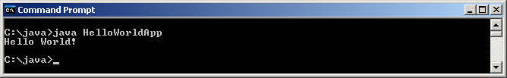

The program prints "Hello World!" to the screen.

Congratulations! Your program works!

Następny program do samodzielnej kompilacji;

import java.io.*;  
  
  
class Czytanie {  
  
public static void main(String args[]) throws IOException {  
     int ch;  
      while (true) {  
        System.out.print(">");  
        StringBuffer sb = new StringBuffer();  
        while ( (ch = System.in.read()) != 13) {  
          sb.append( (char) ch );  
        }  
          
        System.out.println(sb.toString());  
        sb = null;  
      }   
  
  
}   
}